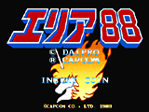
FinalBurn Alpha is the successor of FinalBurn that adds more features & compatibility like Neo Geo support to the original that has been discontinued.
It's definitely worth a try.

